www.StudentTranscripts.gov.bc.ca
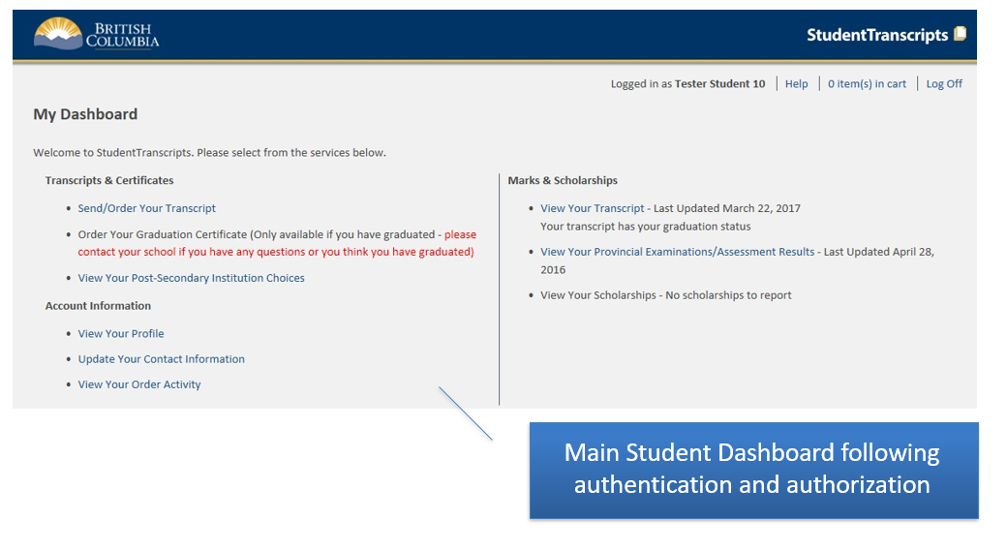

Important Information for Students
Students must register for a BC Government account, a BCeID before accessing the StudentTranscripts Service.
Video 1 – Registering for a BCeID and accessing STS
https://youtu.be/lzmY0WeTfFs
Video 2 - How to order/send a transcript for a PSI
https://youtu.be/SSo_U7XmH8k
Video 3 – How to send a transcript to an employer or yourself
https://youtu.be/QoV4K6Hdz2k

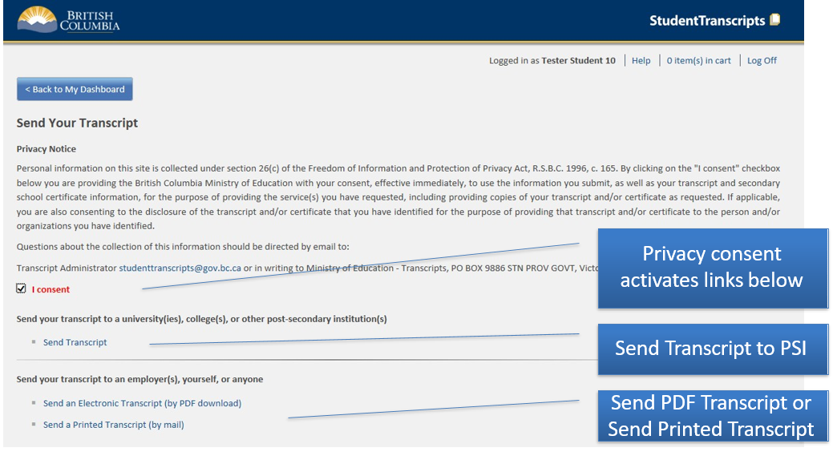

How to find your PEN
https://www2.gov.bc.ca/gov/content/education-training/k-12/support/pen-services/pen
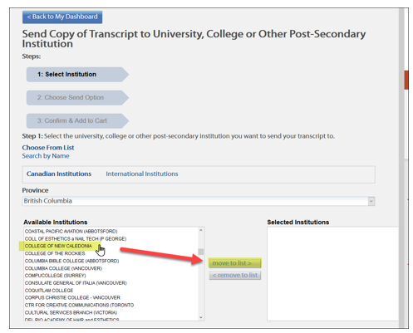
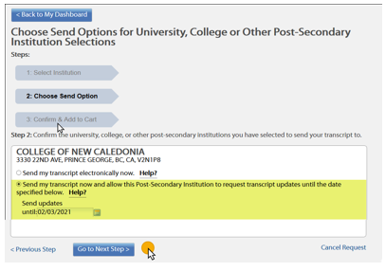

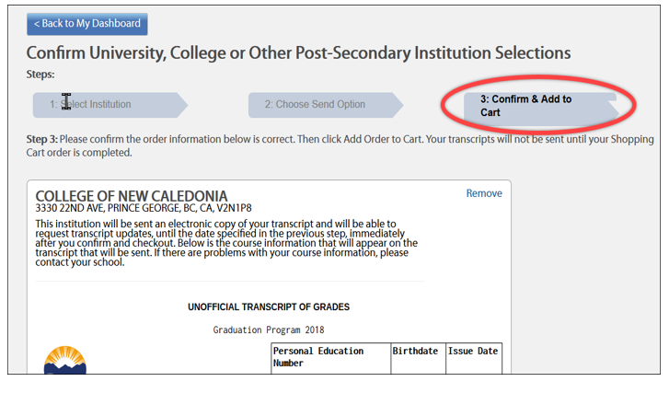

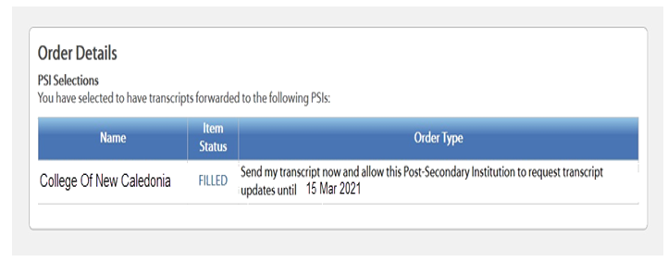

Completed!

