Goal Setting Assignment

The intention of this assignment is to provide students with the opportunity to reflect on their future plans and to give you something to think about as you complete the Goals section of your Professional Portfolio.
Having goals is important but it is also important to understand that goals alone aren't the be all and end all of success. Your process for achieving identity achievement is also important and your goals should reflect where you are in terms of exploration and commitment. Some students might have very detailed goals about a specific trade or career path while other students may have goals related to exploring possibilities and finding passions. Either of these types of goal are acceptable and your ultimate success will likely depend on your openness to examining where you are in terms of identity development.

Part 1:
Watch the YouTube video titled James Marcia’s Adolescent Identity Development & answer the questions about exploration and commitment.
James Marcia's Adolescent Identity Development
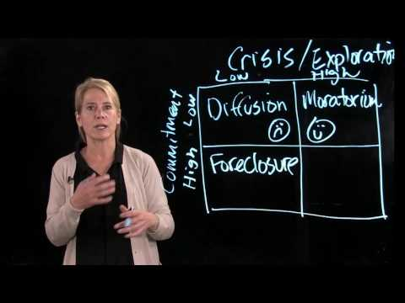

Part 2:

Watch the YouTube video titled SMART Goals – Quick Overview & develop goals SMART goals for 1, 5 and 10 year periods.

SMART Goals - Quick Overview
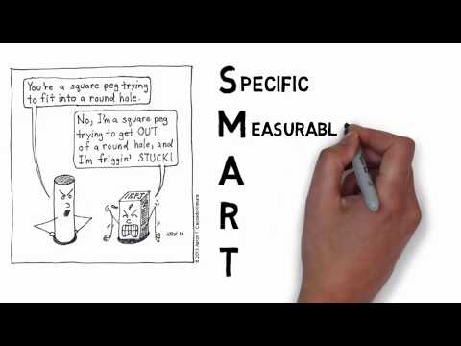

Assessment:

1 | 2 | 3 | 4 | 5
Incomplete | Answers are present but lack detail and formatting. | Answers are complete & follow a SMART format. | Answers are detailed and specific. | Answers are detailed, insightful and specific to the student.

